**ELC - Aqua Runtime control SNOW Exemption template**

**Submitted to**

**By**

**Wipro Technologies**

**Revision History**

|  |  |  |  |  |
| --- | --- | --- | --- | --- |
| **Version** | **Date of Revision** | **Description of Change** | **Reason for Change** | **Reviewed By** |
| 1.1 | 18-Nov-24 | Initial Draft | NA | Mihirkumar |
|  |  |  |  |  |
|  |  |  |  |  |

**Author/Reviewer/Approvals**

|  |  |  |  |
| --- | --- | --- | --- |
| **Name** | **Designation** | **Responsibility** | **Date** |
| Mihirkumar Jani | Consultant | Author | 18-Nov-24 |
| Kannan Kuppusamy | Technical Lead | Reviewer | 18-Nov-24 |
| Felix Jebamani | Lead Consultant | Reviewer | 18-Nov-24 |
| Salama, Omar | Lead | Reviewer | 19-Dec-24  [CST-1252](https://jira.esteeonline.com/browse/CST-1252) |
| Jamshid Abedi | Executive Director | Approver |  |

**Table of Contents**

Objective of the Document 3

1.0 Purpose and Scope 3

2.0 SNOW - Aqua Runtime control Exemption 4

# Objective of the Document

This document explains the Aqua Runtime Control SNOW Exemption Template, which provides guidance on creating ServiceNow exception tickets for Aqua Runtime Control when needed.

# 1.0 Purpose and Scope

The purpose of this document is to provide guidance and instructions for creating ServiceNow exception tickets for Aqua Runtime Control exemptions, if needed.

This document applies to all of the Estee Lauder Companies Inc. (the “Company”) Azure AKS clusters environment.

# 2.0 SNOW - Aqua Runtime control Exemption

If the Team requires an exception based on initial analysis, they can apply for an exception with the security team. For the exemption process, please refer to the following link:

<https://servicenow.elcompanies.com/esc?id=sc_cat_item&sys_id=9570b8af1ba3e55486a72f462a4bcbf5>

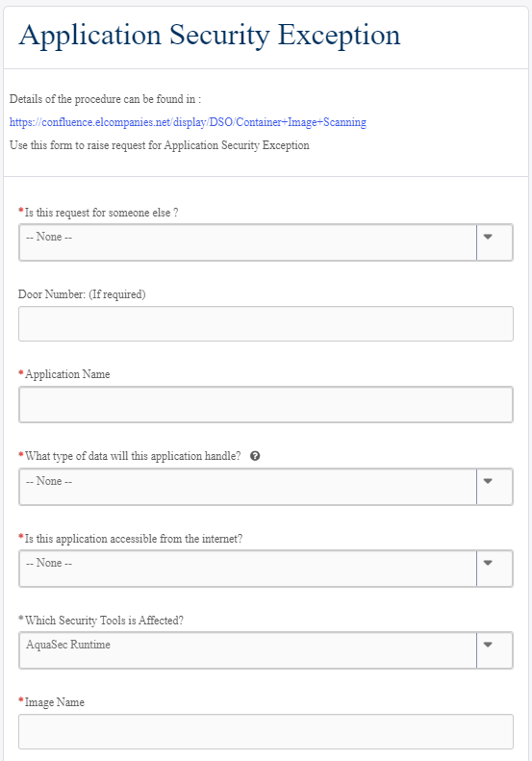

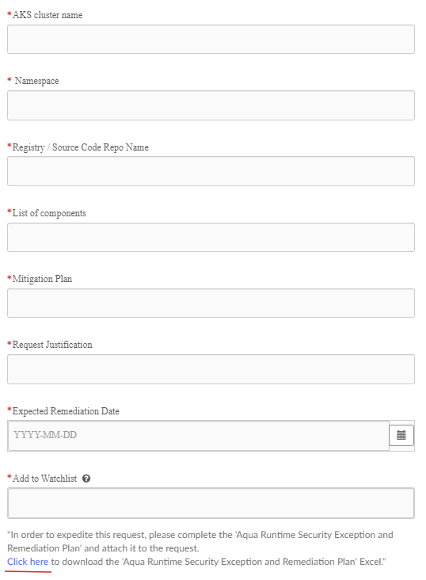

**Need to provide all details in the request form:**

Is this request for someone else?

-- None –

Yes

No

Application Name

(Select application name)

What type of data will this application handle?

-- None –

Highly Sensitive

Internal

Public

Sensitive

Is this application accessible from the internet?

-- None –

No

Yes

Which Security Tools is Affected?

AquaSec Runtime

Image Name

(Provide Image name)

AKS cluster name

(Provide AKS cluster name)

Namespace

(Provide Namespace name)

Registry / Source Code Repo Name

(Provide Registry / Source Code Repo name)

List of components

(Please provide Resource)

Mitigation Plan

(Please provide mitigation plan)

Request Justification

(Please provide business justification)

Expected Remediation Date

(Please provide Expected Remediation Date)

Add to Watchlist

Note: please download excel file and fill it and attach in the requires.

